We Gather as God’s People
December 24, 2023 Christmas Eve 6 pm

Prelude

Welcome

Hymn # 133 O Come, All Ye Faithful

Advent Candles & Christ Candle Lighting
The Dewyer Family

Interactive Christmas Story

Hymn # 122 Silent Night

Scripture Reading John 1:5, 9-14
The light shines in the darkness,
and the darkness can never extinguish it.

5 The light shines in the darkness but the darkness did not comprehend it.

9 The one who is the true light, who gives light to everyone, was coming into the world.

10 He came into the very world he created, but the world didn’t recognize him. 11 He came to his own people, and even they rejected him. 12 But to all who believed him and accepted him, he gave the right to become children of God. 13 They are reborn—not with a physical birth resulting from human passion or plan, but a birth that comes from God.

14 So the Word became human and made his home among us. He was full of unfailing love and faithfulness. And we have seen his glory, the glory of the Father’s one and only Son.

Message Light Up the World
Rev. Susanne M. Bendoraitis

Hymn #134 Joy to the World!

Prayer & Offering Rev. Dr. Tom MacMillan

Charge & Benediction

Postlude Jingle Bells

WELCOME AND MERRY CHRISTMAS!

We joyfully greet and welcome all to this service on this holy night.

We have many ministries, fun events, and ways to become more connected with God, friends, and family. We’d love for you to join us! For additional information on all the ministry opportunities JKPC offers, visit our website at johnknoxpc.org.

Worship, Sunday School, & Nursery
at John Knox Presbyterian Church
Sunday Mornings at 10:00 am

Toddler play group at John Knox:
Toddler playgroup will resume on Thursdays in 2024, beginning January 4. This playgroup is designed for toddlers of all abilities and their caregivers and we’re a judgement-free group! It’s an opportunity for toddlers to get a mini ‘preschool’ experience and play together as well as for caregivers to find community. Please contact Denise Pappu (dpappu@johnknoxpc.org) if you plan on joining us and so you can be added to our email list. Feel free to spread the word!

CHRISTMAS EVE
At John Knox Presbyterian Church

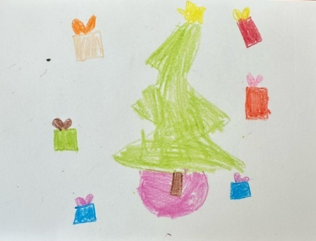
Artwork by Trinity D.

Family Service
December 24, 2023
6:00 pm

